System requirements

Installation

Galileo Data Analysis Program does not require a particularly powerful computer, these are the minimum requirements:
- Windows 95/98/ME or NT/2000/XP
- Pentium Processor
- 16 MB RAM memory
- 10 MB of Hard Disk space
- Floppy disk drive or Internet connection

Installation

- Insert the floppy diskette in the floppy drive and double click the “Setup.exe” icon, wait for a few seconds until the program starts.
- Press “Next” on the first window.
- Click on “Browse” on the second window so as to decide which directory to use to install the program; then press “Next”.
- Please enter the folder name which will hold the shortcut to the program in the “Start” menu; then press “Next”.
- Please verify that the data shown are correct, then press “Next” and wait until the installation is complete.
- The last window allows you to decide whether to launch the program once the installation is finished; then press “Finish”.
The program

Galileo is made up of three different windows, and a console:

- Main window
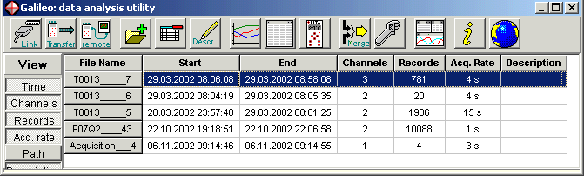

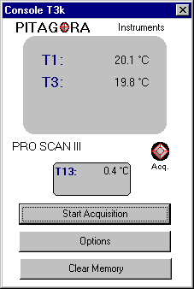
- Data window Console
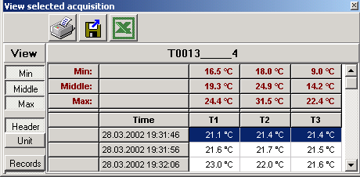

- Graphs window
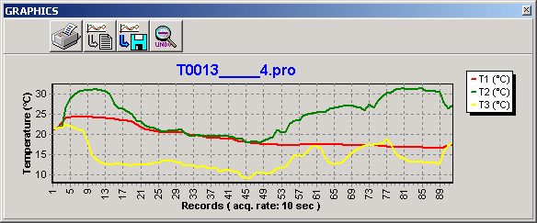

These windows are explained in the following paragraphs:
Main window principale
The Main window is used to communicate with the ProScan unit, to download data, shows the most important information, and can access all auxiliary Galileo functionality. When you decide to choose one of these data sets or files, the other two windows will show it in detail.
The following paragraphs describe the Main window functionality:

Data Downloading

In order to transfer data from the ProScan to the PC or to perform remote operations, the ProScan must be connected to the PC using the enclosed serial RS-232 communications cable and it must be turned on. Once the link has been established the ProScan will produce a beeping sound. The unit must be on and in data view mode (with or without probes). If the ProScan were within a submenu, the communication link would not be established (the program itself will provide instructions in case of problems).

Once connected, the only thing the user must do is to press the Link button so as to start the communications session between the PC and the ProScan unit.

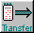
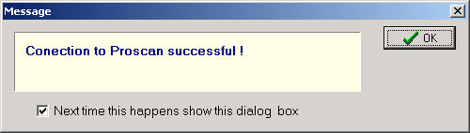
The message on the left appears on the PC screen, so as to confirm (if successful) or with another message in case of connection problems. Once the communication has been established, the Link button shows a communications arrow, now it is possible to press the Transfer button.
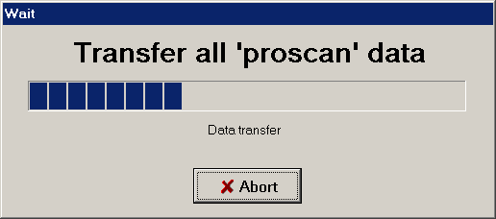
The Transfer window on the right will appear on the screen, and the data will be saved in the ProScan predefined directory created by the program within the Documents directory or folder.
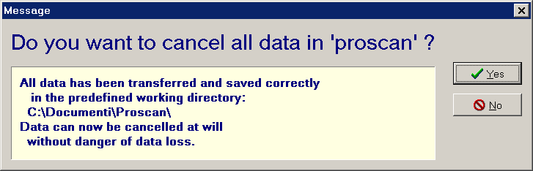
Once the transfer has been completed successfully, the following window appears requesting the cancellation of the data still present inside the ProScan memory; if this data is not to be transferred again to other PCs, you can delete it so as to free memory space within the ProScan unit. The data is still stored within the “..\Document\ProScan” folder and can also be transferred to other computers by simply copying the files with the “*.pro” extension.
The Main window shows the list of data files downloaded during the transfer process displaying the following information:
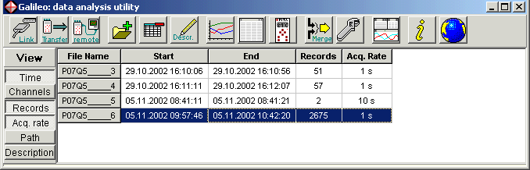
- File Name: the file name is made up of the serial number corresponding to the ProScan unit used, and a sequential number also generated by ProScan.
- Start/End: acquisition time period.
- Channels: number of channels used.
- Records: number of stored records.
- Acq. Rate: acquisition frequency.
- Path: folder where the file is stored.

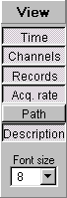
- Description: data description or personal comments; can be manually added by pressing the Description button on the menu.
Apart from the first label field, the label fields on the left can be displayed or hidden by enabling or disabling them from the View panel. Table text size can also be modified from the panel with the “Font size” field found immediately under the View menu.

Remote Acquisition

Remote acquisition mode allows the user to read data from ProScan and to store it automatically and directly in a computer file.
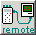
In order to enable remote acquisition, just turn a ProScan unit on, establish the serial link to the PC and click the remote key on the Main window.
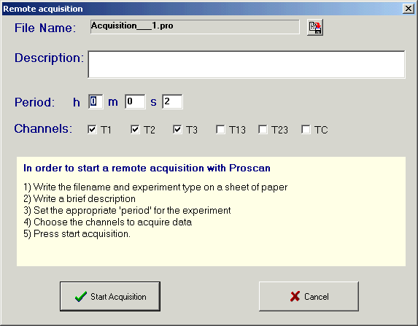
Then, the options selection window appears to as to choose the desired remote acquisition options which include:
- File Name: this file name is automatically generated by the system, however it can be modified by clicking this key and writing a new file name and eventually a new working directory or folder.
- Description: arbitrary description concerning the type of experiment up to a maximum of 80 characters.
- Period: time that passes between one memorized measurement and the next. It is important to set it correctly according to the experiment performed, otherwise you may end up with too few or too many data records.
- Channels: Allows the user to select the channels that will acquire data.
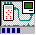
Once the “Start Acquisition” button has been clicked on, a remote file is created which appears in red as “Remote<File Name>”, in the Main window. The existence of a remote acquisition session is signaled by the movement on the bar, and the fact that the remote button looks pressed.

- Main Window showing Remote acquisition file active.
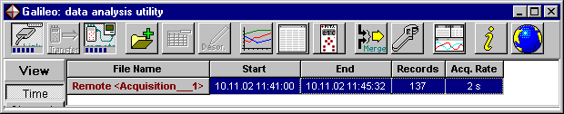

As long as the remote acquisition is active, that file cannot be either modified or removed from the list.
In order to interrupt remote acquisition, just click the remote button on the Main window, and at that moment, the file looses its red marking and it becomes a regular file.
If the remote file is selected and either the Data or Graph windows are active, all measurements are displayed, and are also added in real time.

ATTENTION: in cases where the experiment is very “important”, we strongly recommend not to use remote acquisition, since direct acquisition with ProScan is much more reliable, it does not depend on a PC serial link.
Remote acquisition from a PC could be hindered by other application programs running simultaneously on your PC or system errors which could halt the acquisition process.

Merging Data Files (MERGE)

The merging functions we present are multiple and extremely powerful, in fact this window allows the user to merge data from the same experiment or from different acquisitions in three different modes:
- Align: merging data from different experiments all realigned to the acquisition with the oldest date and time. Example: the same experiment has been performed three times and the user desires to confront all data in a single graph.
- Merge: combines the data in parallel keeping the original “time lines”.

Example: merging data for the same experiment but coming from multiple ProScan instruments used simultaneously.
- Add: combines data in a sequence maintaining the original “time lines”.
Example: allows the user to combine in a single file, data acquired for the same experiment with several interruptions (Start/Stop/Restart).

The Merge window can be called by clicking the “Merge” button .
The Merge Data Files Window allows the user to perform the following functions:
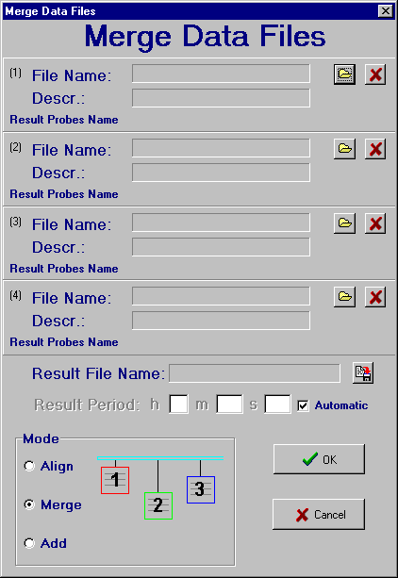
- Select files up to a maximum of four, all generated by ProScan by clicking the corresponding button .
- Assign a file name to the resulting file from the merging of data files by clicking the Result File Name button .
- Set the acquisition period for the resulting file, by removing the check mark from the “Automatic” check box and entering the desired period.
- Choose the desired combination mode, (“Align”, ”Merge” or ”Add”).
ATTENTION: The user can only merge files that were generated directly by a ProScan instrument; data generated by previous merges or from remote acquisitions cannot be recombined.

Additional functions

- Opening files previously downloaded:
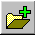
press the Open button and select the desired file.

- Removing single files from the list:
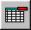
select the file names and press Delete on the keyboard or on the program. The files removed from the list still remain in the hard disk.
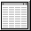
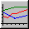
- In order to display or hide the other two windows, press the button for the Data window to appear or disappear, and/or the Graph button for the Graph window respectively.
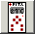
- In order to activate the console to view remote data being acquired by ProScan, and to set the remote operation of the instrument press the console button ; for more information please refer to the specific chapter.
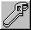
- In order to modify the unit of measure, the precision on the temperature reading, the date format and the language, please open the options window by pressing this button:
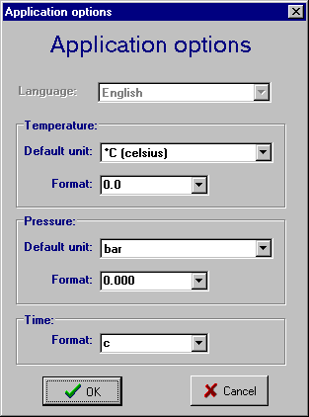
  - Therefore, the user can select the desired units of measurement for each physical dimension and the format for the desired number of decimals after the point.
  - The date format uses the windows convention where “c” gives the complete date with hours and minutes, “t” gives only the hours and minutes, “hh” shows the hours, “mm” shows the minutes and “ss” shows the seconds. It is also possible to insert formats which are not present in the options list, such as:
“dd.mm hh:mm:ss” will give the date with the days and months separated by a dot (dd.mm) and the hours, minutes and seconds separated with colons (hh:mm:ss). Each letter is the initial of each name in English (d:day).
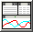
- In order to automatically restablish the position of the three principal Galileo windows, click the button; clicking the enlargement button causes the same effect.
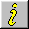
- Further information on the program version, date of last upgrade, etc, can be displayed by pressing .

- Software upgrades can be downloaded from our web site by visiting www.pitagora.ch/download.htm or by pressing this button
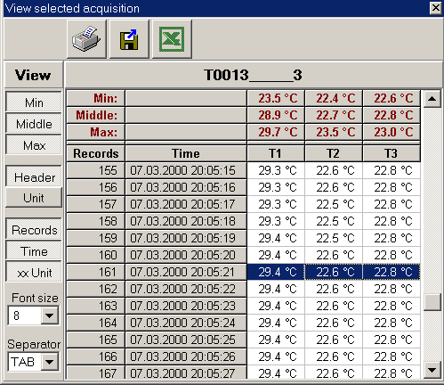
Data window wwindowFinestra dati
Once a file has been selected from the list displayed on the Main window, the Data window (shown here on the left), shows all the single data records contained in the selected file, displaying the following information:

- Data acquired by each of the probes used.
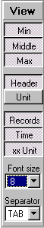
- Min: displays the minimum value for a single probe or channel.
- Middle: displays the average value for a single probe or channel.
- Max: displays the maximum value for a single probe or channel.
- Header: title for each field.
- Unit: units of measurement for the single line.
- Records: record numbers in ascending order.
- Time: instant in which the data record was stored.
- xx Unit: displays both the value and the unit of measure within the field.
All these fields can be displayed or hidden, except the numerical values, by pressing each label to enable/disable them on the View menu.
The characters’ size on the table can also be modified by changing the Font size field immediately under the View menu.

Printing and exporting

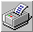
- Before printing any data, one must bear in mind that all data will be printed in exactly the same format in which they are formatted on the window, that is to say only with the fields and the units of measure activated during the visualization. It is also possible to print only a part of the data sequence by selecting the desired part, clicking and dragging the mouse. Press the button to print and control the printer parameters.

- Exporting data works in the same way as printing, it changes according to the selections made for the display. The data can be exported in two different ways:

  - Exporting directly to Microsoft Excel: once the Excel button has been pressed, you must choose the location for the file to be exported in text format (.txt). Then the file will be automatically opened within Excel where the file will be then saved in Excel format (.xls).
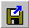
  - Exporting in text file format (.txt): once the text exporting button is pressed, you must choose the location for the file to be exported. The data table will be exported perfectly formatted in the text file, and the field separators will vary according to the selected element in the Separator command.

Graphs window
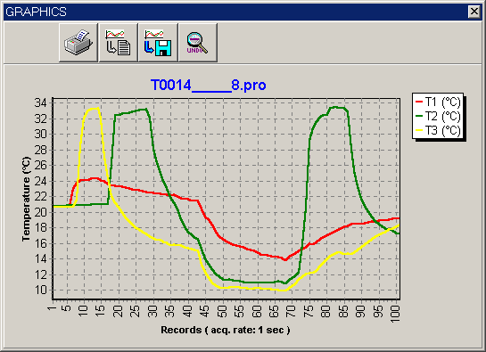
Once a file has been selected in the Main window, the Graphs window will show a detailed graph representing each and every value in the file.

zoom


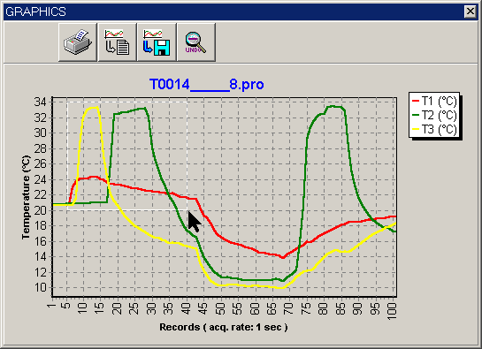
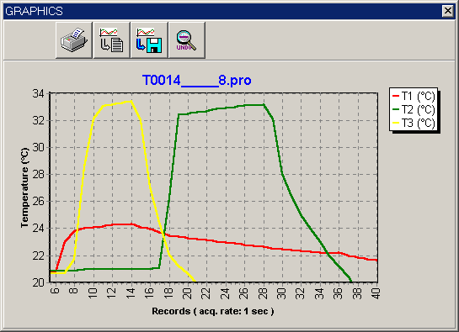
In order to zoom in on particular areas of this graphs, click and hold the mouse button and drag it so as to form an enclosing zooming rectangle or window. Once the mouse button is released, the graph will zoom in or enlarge itself, adjusting the proportions together with the numbers on the scales. The rectangle must be designed starting at the top left angle and ending at the bottom right angle. Using a different order for the starting and ending point will restore the original full view. The same restoration or reset effect can be obtained by pressing the loop minus button . Dragging the graph with the right mouse button shifts the graph right or left as desired within the same zoom factor.
Please note that for all the following commands, the graphs are considered as a whole within the window they are displayed, without buttons and maintaining the proportions as displayed as well. Therefore, we recommend enlarging the Graphs window to a maximum prior to printing, thus obtaining the best format.

Printing

Set the Graphs window to the desired enlargement and choose the zoom level desired. Press the button and check the printer setup and properties.

exporting

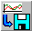
Set the Graphs window to the desired enlargement and choose the zoom level desired. Press the button and choose the destination folder or directory, the format and the file name.

copy

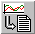
Set the Graphs window to the desired enlargement and choose the zoom level desired. Press the button which acts as a windows “copy” function. Now you can paste the desired graph into another program.

InformaTion

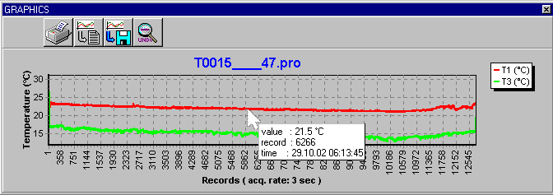
Clicking the left mouse button close to a point in a graph, the user obtains a use-ful informative label with: instant measured value, record number, date and time.
Console
The “Console” is the window which allows the user to view and control the instrument through the serial RS232 link and is set active by clicking the button on the Main window.
This functionality is very convenient when the instrument must be placed in an area with difficult accessibility.
The “console” is also very practical to set the acquisition parameters directly from your own PC or to monitor an experiment from a certain distance.
The “console” is slightly different for each instrument model, nevertheless it always allows the user to perform the following:
- View the measured data on the represented virtual instrument displayed in a similar manner to the real one.
- Set all the desired instrument options from a comfortable and user friendly window.
- Clear the instrument’s memory making space for the new experiments.

ATTENTION: make sure you have downloaded and saved the data on your PC before canceling the memory contents of each instrument; clearing the memory is not a reversible operation.

- Start or halt an acquisition session remotely on an instrument using the PC, having the possibility to verify the memory available in percentage or in acquisition time left.

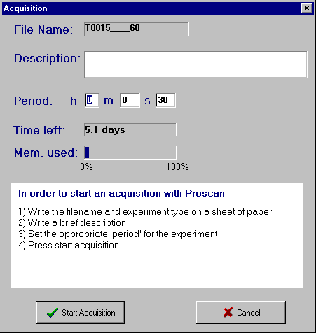

ATTENTION: this type of acquisition should not be confused with Remote acquisition from a PC, in fact when the user starts an acquisition session from the “console”, the data is stored in the instrument and must be downloaded on to the PC later, using the “Transfer” procedure.

Disclaimer
During normal program operating conditions, it is very difficult to loose any data. Nevertheless, Pitagora S.A. explicitly denies any responsibility for data losses, errors of operation, malfunctions or any damages resulting from using this program or any of Pitagora’s products, or for any other cause.

For the latest manual version or additional languages versions, please visit and download them from our web site at www.pitagora.ch.

All information contained in this manual are subject to changes without prior notice.

